Hamza
24k-3065
Lab-09
Task-01
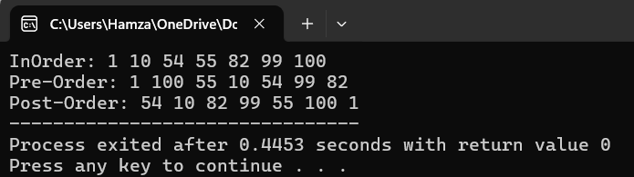
#include<iostream>
using namespace std;
class Node{
public:
int data;
Node* left;
Node* right;
Node(int value){
data=value;
left=NULL;
right=NULL;
}
};

Node* Insert(Node* head,int value){
if(head==NULL){
Node* newNode=new Node(value);
head=newNode;
head->left=NULL;
head->right=NULL;
return head ;
}
if(value<head->data){
head->left=Insert(head->left,value);
}
else{
head->right=Insert(head->right,value);
}
return head;
}
void Inorder_Travesel(Node* head){//LNR
if(head==NULL){
return ;
}
Inorder_Travesel(head->left);
cout<<head->data<<" ";
Inorder_Travesel(head->right);
}
void PreOrder_Travesel(Node* head){//NLR
if(head==NULL){
return;
}
cout<<head->data<<" ";
PreOrder_Travesel(head->left);
PreOrder_Travesel(head->right);
}
void PostOrder_Travesel(Node* head){
if(head==NULL){

return;
}

PostOrder_Travesel(head->left);
PostOrder_Travesel(head->right);
cout<<head->data<<" ";
}
int main(){

Node* head=NULL;
head=Insert(head,1);
head=Insert(head,100);
head=Insert(head,55);
head=Insert(head,10);
head=Insert(head,99);
head=Insert(head,54);
head=Insert(head,82);
cout<<"InOrder: ";
Inorder_Travesel(head);
cout<<endl;
cout<<"Pre-Order: ";
PreOrder_Travesel(head);
cout<<endl;
cout<<"Post-Order: ";
PostOrder_Travesel(head);

}
Task-02
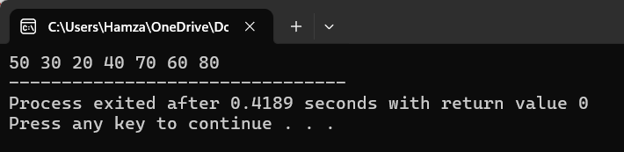
#include<iostream>
#include<stack>
using namespace std;

class Node{
public:
int data;
Node* left;
Node* right;
Node(int value){
data=value;
left=NULL;
right=NULL;
}
};
Node* Insert(Node* head,int data){
if(head==NULL){
Node* newNode=new Node(data);
head=newNode;
head->left=NULL;
head->right=NULL;
return head;
}
if(data<head->data){
head->left=Insert(head->left,data);
}else{
head->right=Insert(head->right,data);
}
return head;
}

void Travse(Node* head){
if(head==NULL){
return;
}
stack <Node*> s;
s.push(head);

while(!s.empty()){
Node* temp=s.top();
s.pop();
cout<<temp->data<<" ";

if(temp->right){
s.push(temp->right);
}
if(temp->left){
s.push(temp->left);
}

}
}
int main(){
Node* head=NULL;
head=Insert(head,50);
head=Insert(head,30);
head=Insert(head,20);
head=Insert(head,40);
head=Insert(head,70);
head=Insert(head,60);
head=Insert(head,80);

Travse(head);
}
Task-03
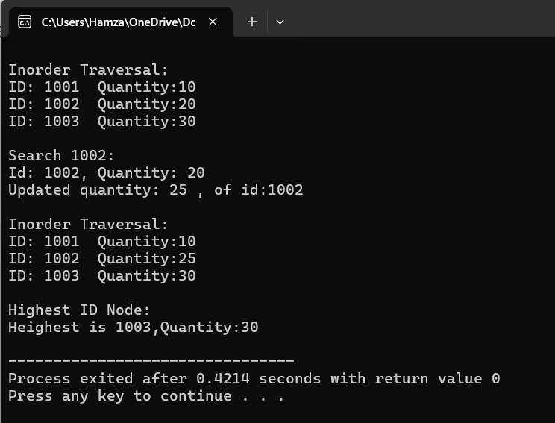
#include<iostream>
using namespace std;
class Node{
public:
int quantity;
int id;
Node* left;
Node* right;
Node(int q,int d){
quantity=q;
id=d;
left=NULL;
right=NULL;
}
};
class Product{
public:
Node* head;
Node* Insert(Node* head,int q,int d){
if(head==NULL){
Node* newNode=new Node(q,d);
head=newNode;
head->left=NULL;
head->right=NULL;
return head;
}
if(d<head->id){
head->left=Insert(head->left,q,d);
}
else{
head->right=Insert(head->right,q,d);
}
return head;
}
bool Search(Node* head,int d){
if(head==NULL){
return false;
}
if(head->id==d){
cout<<"Id: "<<head->id<<", Quantity: "<<head->quantity<<endl;
return true;
}

if(d<head->id){
Search(head->left,d);
}
else{
Search(head->right,d);
}
}
void Update(Node* head,int d,int q){
if(head==NULL){
return;
}
if(head->id==d){
head->quantity=q;
cout<<"Updated quantity: "<<q<<" , of id:"<<d<<endl;
return;
}
if(d<head->id){
Update(head->left,d,q);
}
else{
Update(head->right,d,q);
}
}
void Heighest(Node* head){
if(head==NULL){
return;
}
while(head->right!=NULL){
head=head->right;
}
cout<<"Heighest is "<<head->id<<",Quantity:"<<head->quantity<<endl;
}
void Inorder(Node* head){
if(head==NULL){
return;
}
Inorder(head->left);
cout<<"ID: "<<head->id<<" Quantity:"<<head->quantity<<endl;
Inorder(head->right);
}
};
int main() {
Product p;
Node* head = NULL;

head=p.Insert(head, 10, 1001);
head=p.Insert(head, 20, 1002);
head=p.Insert(head, 30, 1003);

cout<<"\nInorder Traversal:" <<endl;
p.Inorder(head);

cout<<"\nSearch 1002:" <<endl;
if(!p.Search(head, 1002)){
cout << "Not found!" << endl;
}

p.Update(head, 1002,25);
cout << "\nInorder Traversal:" << endl;
p.Inorder(head);

cout << "\nHighest ID Node:" << endl;
p.Heighest(head);
}
Task-04
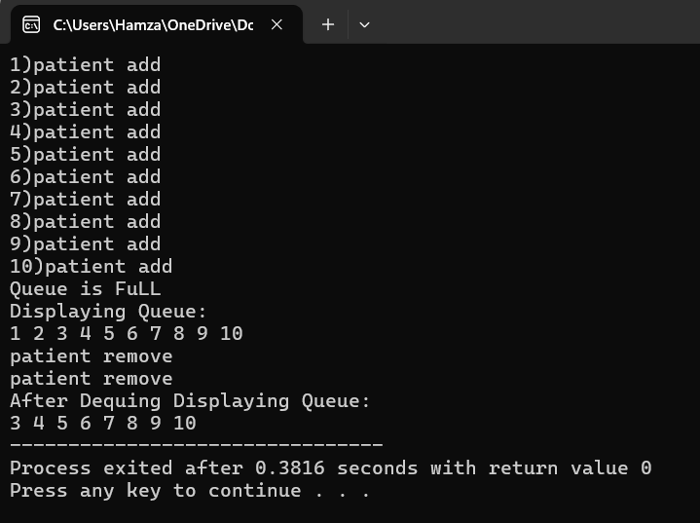
#include<iostream>
using namespace std;
class Queue{
int front,rear;
int arr[10];
int capacity;
public:
Queue(){
front=-1;
rear=-1;
}
void Equeue(int id){
if(isFull()){
cout<<"Queue is FuLL"<<endl;
return;
}
if(isEmpty()){
rear=front=0;
arr[rear]=id;
cout<<id<<")patient add"<<endl;
return;
}
rear++;
arr[rear]=id;
cout<<id<<")patient add"<<endl;

}
int Dequeue(){
if(isEmpty()){
cout<<"Queue UnderFlow"<<endl;
return -1;
}
int id=arr[front];
for(int i=front;i<rear;i++){
arr[i]=arr[i+1];
}
rear--;
cout<<"patient remove"<<endl;
return id;
}
bool isEmpty(){
return(front==-1 || front>rear);
}
bool isFull(){
return rear==9;
}
void display(){
if(isEmpty()){
cout<<"Queue is Empty"<<endl;
return ;
}
for(int i=front;i<=rear;i++){
cout<<arr[i]<<" ";
}
}
};
int main(){
Queue q;
q.Equeue(1);
q.Equeue(2);
q.Equeue(3);
q.Equeue(4);
q.Equeue(5);
q.Equeue(6);
q.Equeue(7);
q.Equeue(8);
q.Equeue(9);
q.Equeue(10);
q.Equeue(1);
cout<<"Displaying Queue: "<<endl;
q.display();
cout<<endl;
q.Dequeue();
q.Dequeue();
cout<<"After Dequing Displaying Queue: "<<endl;
q.display();

}
Task-05
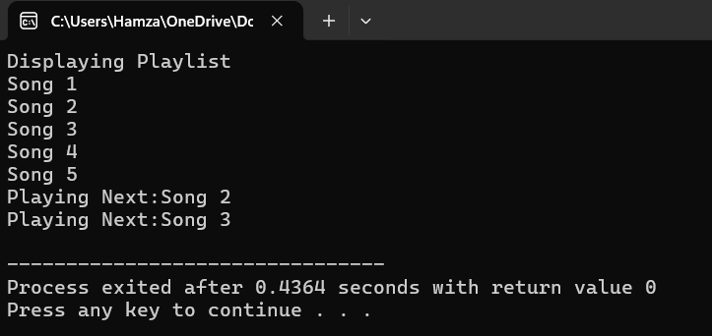
#include<iostream>
#include<cstring>
using namespace std;

class Playlist{
int front,rear,capacity;
string song[5];
public:
Playlist(){
front =-1;
rear=-1;
capacity=5;
}
bool isEmpty(){
return(front==-1 && rear==-1);
}
bool isFull(){
return((rear+1)%capacity==front);
}
void addSongs(string s){
if(isFull()){
cout<<"Playlist is Full"<<endl;
return;
}
if(isEmpty()){
rear=front=0;
song[rear]=s;
return;
}
rear=(rear+1)%capacity;
song[rear]=s;
}
void PlayNext(){
if(isEmpty()){
cout<<"Playlist is Empty";
return;
}
front=(front+1)%capacity;
cout<<"Playing Next:"<<song[front]<<endl;
}

void display(){
if(isEmpty()){
cout<<"PlayList is Empty";
return;
}
int i=front;
while(true){
cout<<song[i]<<endl;
if(i==rear){
break;
}
i=(i+1)%capacity;
}
}
};
int main(){
Playlist p;
p.addSongs("Song 1");
p.addSongs("Song 2");
p.addSongs("Song 3");
p.addSongs("Song 4");
p.addSongs("Song 5");
cout<<"Displaying Playlist"<<endl;
p.display();
p.PlayNext();
p.PlayNext();
}
Task-06

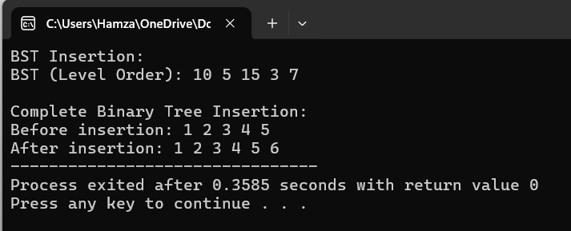
#include<iostream>
#include<queue>
using namespace std;
class Node{
public:
int data;
Node* left;
Node* right;
Node(int value){
data=value;
left=NULL;
right=NULL;
}
};
Node* head=NULL;
void BST_Insert(int value){
Node* newNode=new Node(value);
if(head==NULL){
head=newNode;
return ;
}
else{
Node* temp=head;
while(temp!=NULL){
if(newNode->data==temp->data){
cout<<"No duplicates allowed";
return;
}
else if((newNode->data<temp->data)&& (temp->left==NULL)){
temp->left=newNode;
break;
}
else if(newNode->data<temp->data){
temp=temp->left;
}
else if((newNode->data>temp->data)&& (temp->right==NULL)){
temp->right=newNode;
break;
}
else{
temp=temp->right;
}
}
}
}
Node* CompleteTree(Node* head,int value){
Node* newNode=new Node(value);
if(head==NULL){
head=newNode;
return head;
}
queue<Node*> q;
q.push(head);
while(!q.empty()){
Node* temp=q.front();
q.pop();
if(temp->left==NULL){
temp->left=newNode;
break;
}else{
q.push(temp->left);
}
if(temp->right==NULL){
temp->right=newNode;
break;
}else{
q.push(temp->right);
}
}
return head;
}
void LevelOrder(Node* head){
queue<Node*> q;
q.push(head);

while(!q.empty()){
Node* temp=q.front();
q.pop();

cout<<temp->data<<" ";
if(temp->left){
q.push(temp->left);
}
if(temp->right){
q.push(temp->right);
}
}
}
int main() {
cout << "BST Insertion:\n";
BST_Insert(10);
BST_Insert(5);
BST_Insert(15);
BST_Insert(3);
BST_Insert(7);
cout << "BST (Level Order): ";
LevelOrder(head);

cout <<"\n\nComplete Binary Tree Insertion:\n";
Node* root = new Node(1);
root->left = new Node(2);
root->right = new Node(3);
root->left->left = new Node(4);
root->left->right = new Node(5);

cout << "
Before insertion: ";
LevelOrder(root);
root = CompleteTree(root, 6);
cout << "\nAfter insertion: ";
LevelOrder(root);

return 0;
}

